EAGLE SKI CLUB TOUR
SUNNMØRE 2025
PROPOSED ITINERARY

The Sunnmøre Alps are noted for their dramatic mountains and excellent snow which lies well into Spring. This trip will be day tours in the region with ascents of typically 1000 – 1200m a day which will equate to approximately 6 – 7 hours out on the mountains.
We shall be based at a very comfortable AirBnB in the small town of Saebo, which has already been reserved.
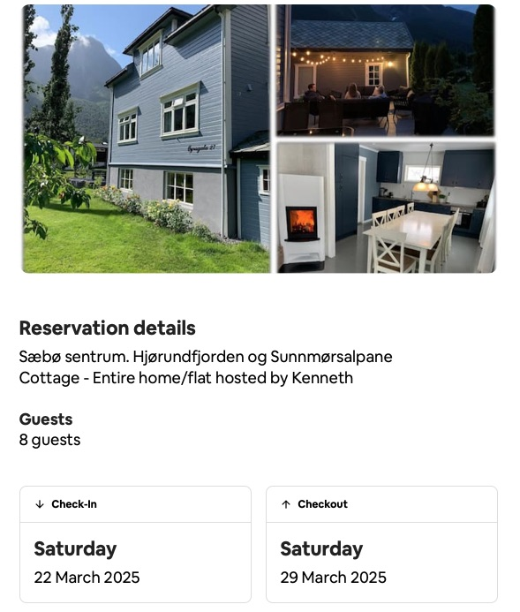

Dates: Saturday 22nd – Saturday 29th March 2025
Travel: The plan currently is to fly to Bergen and then drive with hire cars to Sunnmøre; this tour could link with the following week led by Andrew Duncan to Sogndal. NB I am staying on for the second week so hire cars will also be staying. It is also possible to travel to and from Sunnmøre by bus from Oslo airport via Stryn.
Maps: Available through Kartverket online or map shops

Standard: E2/3, S3, M2

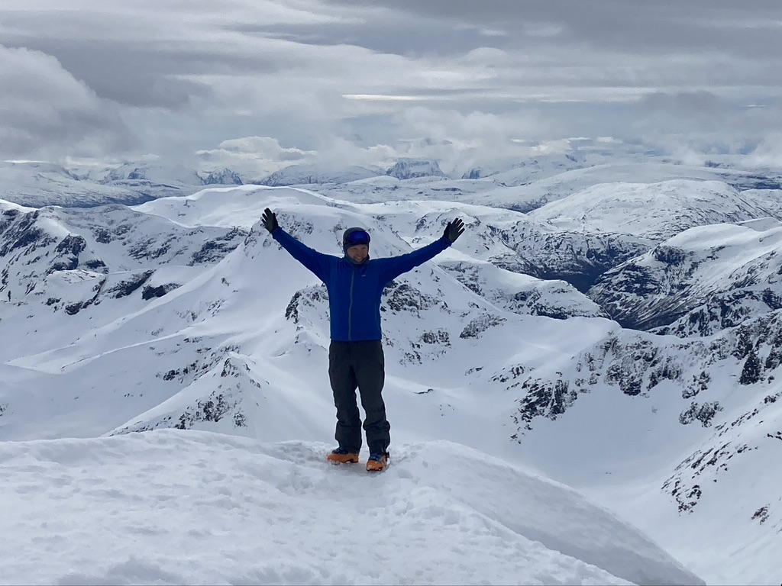
There may be some tricky mountain sections on this tour. Everyone should be familiar with crampons, ice-axe and harschiesen.

Costs: around £200/pp for the apartment and food costs shared – allow about £100 for that and extras such as fuel, etc.

Equipment: usual touring gear including skis, skins, harschiesen, transceiver, shovel, ice axe and crampons. Harnesses are not essential for most of the tours.
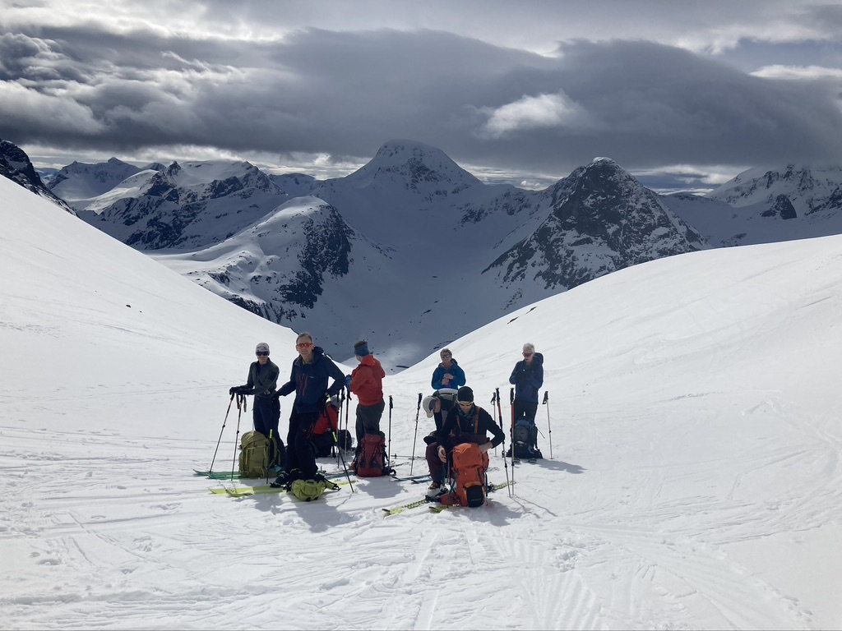
Insurance: a suitable travel insurance including helicopter rescue is compulsory.

I will provide a gear list and nearer the time we can arrange what group equipment we need.

Further details and Applications: Please apply on the standard ESC application form (from website) with a deposit for £120 to cover the property deposit either by BACS transfer to:

A M EDGERTON & P M EDGERTON
Sort code: 40-47-87
A/c No: 01816845

Or send a deposit cheque to the address below.

E-mail: rowanho@dircon.co.uk

Address: Rowan House, Highgate rd., Hayfield SK22 2JL
Phone: 01663-742367

